Mt. Lebanon High School  International Student Program  155 Cochran Road, Pittsburgh, PA 15228  www.mtlsd.org/internationalstudents  School Location: Western Pennsylvania – suburb of Pittsburgh (~10 km from Mt. Lebanon to Pittsburgh – subway access)  City Statistics: 15.6 square kilometers in area; ~33,000 residents  School Statistics: Public high school; grades 9-12; 26 acre campus; ~1800 students; over 70 clubs and organizations; 26 sports teams  Facilities: Library and media center; two large performance theaters; studios for visual arts, dance, music, chorus, and television; labs or science, writing, math, social studies, food and nutrition, and graphics; three full size gymnasiums; indoor swimming pool; fitness room; tennis courts; 7200 seat stadium; running track; academic teaching spaces; cafeteria; student center.  Awards: Niche.com school rankings -- #15 school district in the United States for 2019; National Association of Music Merchants – Best Community for Music Education 2018; US News and World Report – Best High Schools 2017 Silver Award  Curriculum: 19 Advanced Placement courses; 41 Honors courses; 141 Academic courses.  Activities: Interscholastic and intramural sports; symphony orchestra; marching band; literary magazine, newspaper; yearbook; dance company; student government; student leadership; academic games.  To replace anytip text with your own, just select it and start typing. Don’t include space to the right or left of the characters in your selection.  This space is ideal for an intro letter to your readers. As you type, the shaded area will grow with your text.  Warm regards,  Your Friends in Word  Show Off Your Style  You make your fabulous style look easy. So do we.  We’ve created styles that let you match the formatting you see in this template in no time. On the Home tab, check out the Styles gallery to apply any text style used in this newsletter.  Expand Your Horizons  Duplicate the look of one of these pages to add an additional page with just a few clicks. Each page is built for quick and easy layout.  All you need to do is copy a page break to ensure that your new content lands on its own page and then copy the page layout you want to reuse. Read on for help getting that done… |  | Program Administration  Mrs. Carlie McGinty  Unit 3 Principal  Program Director  412-344-2050  cmcginty@mtlsd.net  Mentor Teachers  Mrs. Connie Booth  Mrs. Pam Burrett  Mr. Mark Kernion  Visit our Website for:  - Additional program information  - Admission process/ application information  - Photo gallery

Program Profile  Participating Students  Students participating in our International Student program range from 9th to 11th graders.  Program Highlights  - Student Orientation: Prior to the beginning of the school year, students and their host families meet to share their backgrounds; obtain information helpful for a great start to the school year; meet local students and the whole International Student Program administrative team.  - Teacher Mentors: Each student is assigned an experienced educator to aid in their success throughout the school year.  - Student Meetings: Large group semi-weekly meetings occur throughout the school year for all International Students to aid in their assimilation process into our school and culture.  - English as a Second Language Help: Students identified with a need for ESL instruction will be scheduled for such with an ESL teacher in our school.  - Student Outings: All International Students are invited to take part in student outings sponsored by the International Student Program. Some outings involve both International and resident students who participate in our Global Studies Program.  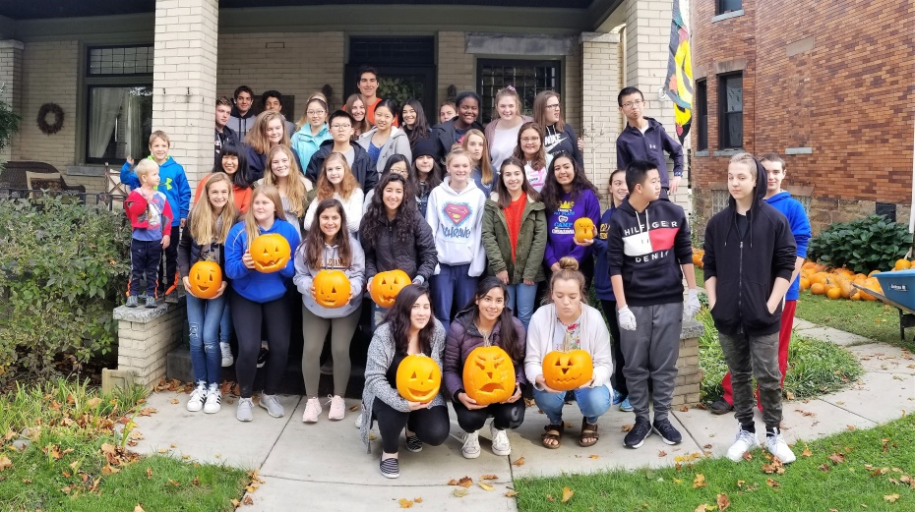  Pumpkin carving in October–  International, ESL and and Global Studies Students |  | 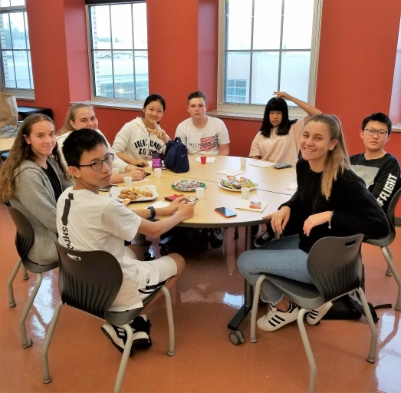  Our Students’ Homelands  Over the past 4 years our students have come from:  Brazil, China, Croatia, Denmark, France, Germany, Italy, Japan, Norway, Pakistan, South Korea, Switzerland and Thailand.

